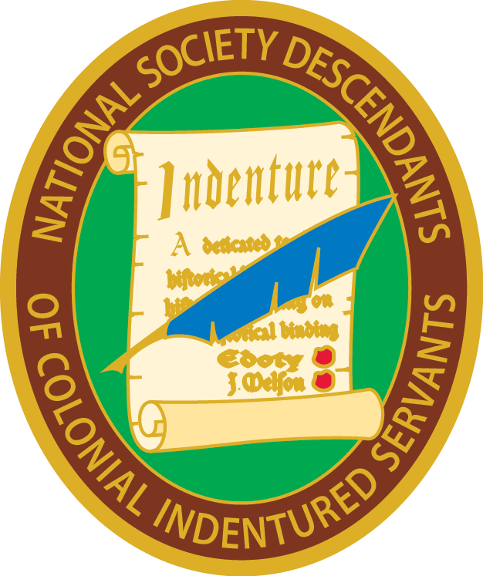Report of Vice President General, NSDCIS
2020

It has been a privilege and honor to found this important Society with President General Sumner G. Hunnewell. It felt like we were re-inventing the wheel sometimes, but we have been off and running for a year-plus now. Registrar General Robin Towns was invaluable as a recent founder of another society and member of Founder’s Fellowship, as was Chaplain General Carla Odom. Sumner and I are indebted to them for all their advice and help.
I have been in charge of the production of all certificates and the mailing of them as well as the insignia for our members. I believe the response to both has been incredibly positive. I also handle any orders for additional insignia.
The Facebook Group and public Page are both excellent ways to recruit new members and as Administrator I have tried to keep them fresh with articles, resources, queries, etc. I have boosted posts that I felt had the potential to be compelling to anyone looking and we have gotten lots of impressions and new “likes.” I try to post about NSDCIS on other lineage Facebook groups, too. I have placed ads for NSDCIS in Georgia state DAR programs for two years. I was scheduled to give the program on Indentured Servants at a local SAR meeting, but it has been postponed due to the coronavirus. At my other lineage society meetings, I try to promote NSDCIS to anyone who will listen.
I have kept in touch with Director Ms. Pat Taylor at Pemberton Hall which is our charitable focus. I am so proud of this Society and appreciate everything all the officers have done to make it happen. Our indentured servant ancestors deserve to be remembered and we are doing a great job of making sure that happens. Thank you to all our officers and members!! It has been a pleasure to serve.

Janet B. Walker, Vice President General
National Society Descendants of Colonial Indentured Servants

