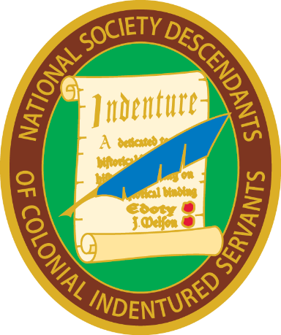
National Society Descendants of Colonial Indentured Servants
President General’s Report – 2020
It certainly has been quite a trek to create a hereditary society from scratch. Thank goodness that I have been surrounded by a cadre of experienced officers. Everyone has done their work admirably. We have done our ancestors a service by pointing out their servitude to make a better life for themselves, which we still experience today.
Other than his official duties, this officer has been busy with the creation and maintenance of the Society’s website. All ancestors and sources used for proof of service have been added quickly after approval from Registrar General Robin Towns. The website and Facebook (maintained by Vice President Janet Walker) are our advertising spaces to the world, so it is important that these be up to date and pertinent. At the moment there are about 75 print and on-line database resources related to indentured servants as well as over 60 approved ancestors on the website. To avoid lockout, the password to the website has been mailed to multiple officers.
I worked with Recording Secretary General Sharon Sowders, who produced our first directory. Subsequent to that, we have set up a shared spreadsheet on Dropbox, allowing me access to the ‘fabulous spreadsheet,’ if our Recording Secretary General is out of pocket.
Also, we had members write articles for our new bulletin, The Passage, which was mailed out earlier this year. This is encouraging as it places less work on the editor’s plate and might entice more to write about their indentured ancestors. Thanks go to Robin Towns for picking up the directory and bulletin and mailing both out.
The nominating committee of Tim Mabee, Sharon Sowders, and Pat Gallagher was formed and the slate is already to be presented in 2021!
All in all, we’ve had an auspicious first year thanks to the board’s input, advice, and assistance!
Respectfully yours,
Sumner G. Hunnewell
President General,
National Society Descendants of
Colonial Indentured Servants

